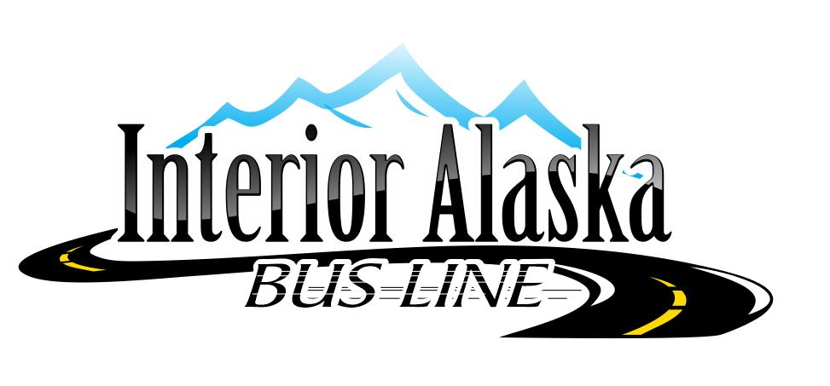Rider Guide

Interior Alaska Bus Line is a non-profit corporation providing transportation to people between Anchorage, Fairbanks, Tok and Northway, including the elderly, disabled, or others who are transportation disadvantaged.

Interior Alaska Bus Line
PO Box 635
Tok, AK 99780
PH: 800-770-6652 Fax: 866-244-5691 email: akbus3@aptalaska.net

It is the passenger’s responsibility to be at scheduled stop prior to the arrival/boarding time. Passengers are responsible for paying their fares by cash or check when boarding unless payment has been made to the office prior to travel. Drivers are able to accept credit/debit cards and contactless payments such as Apple Pay and Samsung Pay on the date of travel as well. Seats are not guaranteed until payment has been made. Passengers may be put on the manifest prior to payment, as a standby, but may be bumped by a paying passenger.
Seat belts must be worn when the vehicle is in motion. Children must follow the State of Alaska seat belt law. It is the responsibility of the person traveling with the child to provide the child restraint device and secure it in the vehicle.
No alcohol, weapons (other than in a locked case), drugs, hazardous items or smoking are allowed on vehicle. Intoxicated or disruptive passengers may be refused service or evicted from the bus at the discretion of the driver with no refund given.
Luggage, Animals, & Freight
- Passengers are allowed 2 suitcases each
- Pets are not permitted on IABL vehicles unless it is a service animal.
- Items too large to be stored on a passenger's lap or between his/her feet shall be secured in the baggage area of the vehicle.
- Highly flammable materials, explosives and all deadly or dangerous weapons are prohibited, as are any illegal drugs.
- Hunting rifles may be transported unloaded, in a locked case, separated from the ammunition. The driver is to be notified by the passenger, and the gun inspected for safe transportation prior to boarding the vehicle.
Luggage weight cannot exceed 50 pounds per bag. Extra luggage (in excess of the 2 allowed per passenger) will incur addition charges. Due to insurance regulations, our drivers are not able to handle luggage. Please follow the driver’s direction when stowing your luggage.
Freight is based on $1 per pound. IABL will transport freight on a “space available” basis after the passengers’ needs have been met.
Freight must be brought to the pick-up location by the customer. Freight must be picked up at the bus stop upon arrival. IABL will not store or keep freight that is not picked-up.
IABL is not responsible for any lost, stolen, or damaged items.
Refunds / Cancellation
Customers who have pre-paid via credit card will be refunded their full fare less a $10 processing fee if they cancel prior to their scheduled departure time. Passengers who are a no-show, no-call will not be refunded. Customers who are being invoiced for their fare will not be charged if they call and cancel prior to their scheduled departure time. No-Show, no-call invoiced customers will still be invoiced for the full fare since we are unable to re-sell their seat.
Transporting Passengers with Disabilities
Travel arrangements must be made at least 2 days prior to travel.
- Passengers will be required to have their mobility devices secured when they are occupying them in the vehicle.
- Service will not be denied if the mobility device cannot be secured or restrained by the vehicle’s securement system.
Passengers with disabilities may request modifications to current service procedures to access our service. To make a request, please call us at 800-770-6652 or email us at akbus3@aptalaska.net. Please submit requests at least the day before the trip. Interior Alaska Bus Line will not charge additional fees for passengers requiring reasonable modifications.

Personal Care Attendants (PA) and Escorts
- IABL provides public transportation. We do not provide specialized care. Drivers deploy lifts for persons using mobility devices and those without mobility devices who cannot navigate the bus steps, secure wheelchairs, and, if in a wheelchair, fasten seatbelts. If additional assistance is needed, IABL recommends traveling with someone who can assist you.
- All PA/escorts are responsible for the care of the passenger they are with. They must board and disembark at the same locations as the passenger.
Service Animals
- Service animals may accompany individuals with disabilities in the vehicle. The DOT ADA regulations define a service animal as any individual animal trained to work or perform tasks for an individual with a disability, including but not limited to guiding individuals with impaired vision, alerting individuals with impaired hearing to intruders or sounds, providing minimal protection or rescue work, pulling a wheelchair, or fetching dropped items.
- Service animals must behave appropriately and remain under the owner’s control. Service animals may not sit on a vehicle seat but must remain in the owner’s lap or at their feet.
- Owners are responsible for any damage or soiling caused by their service animal. Owners may be asked to remove their service animal if it is not under the owner’s control or poses a direct threat to the health and safety of others.
Route Cancellations
Interior Alaska Bus Line may alter and/or cancel scheduled service due to a declared emergency hazardous road or environmental conditions. Transportation services will be restored as soon as conditions allow. Passengers should be aware that under emergency situations, their ride may be canceled or altered without prior notification. IABL will make every effort to contact passengers that are affected, but the nature of the emergency may not allow phone use.
- Declared emergency: A localized, community wide, statewide, or national catastrophic or hazardous event in which a local, state, or federal agency decrees a state of emergency and/or a decreed disaster area.
- Hazardous weather conditions: Adverse road and/or environmental conditions that the driver determines makes it unsafe to operate the IABL vehicle, or as advised by the National Weather Service, Alaska Department of Transportation, or the Alaska State Troopers.
Inclement Weather
During inclement weather buses may be delayed or cancelled. Service delays of more than 1 hour or cancellations will be listed on our website. You may also call the office for up-to-date information. Alaskan winters can be treacherous. Interior Alaska Bus Line recommends the following tips to make your ride a safe and enjoyable experience.
- Always dress appropriately for the weather. Even if you do not wear them, it is a good practice to bring a coat, warm boots, gloves and a hat.
- Assure that you are in a visible, well-lit location when waiting for the bus. Winter days are dark and make driver visibility difficult. Carrying a flashlight or a blinking device can aid in making you more noticeable.
- All regular IABL stops are open year-round and offer a place to get in out of the cold. If you are at a flag-stop location, we recommend waiting in a warm vehicle until the bus arrives. Many locations along our route are not phone accessible and the driver may not be able to contact you to provide an ETA.
- Rides that are cancelled by IABL due to inclement weather will be refunded in full or re-scheduled to best suit the customer’s needs.
Passenger Conduct
Passengers may be refused service and undergo progressive disciplinary action to include suspension (up to and including permanently) from riding the Interior Alaska Bus Line, due to disorderly conduct.
The following actions will be considered to be displays of disorderly conduct. This list is not all inclusive, but should serve as a guide toward understanding the types of actions/behaviors which will result in one’s being denied transport, causing the need for progressive disciplinary action, and may lead to subsequent suspension from the Interior Alaska Bus Line:
- Smoking on the van
- Consuming alcoholic beverages or transporting open alcoholic containers;
- Displaying obvious signs of alcohol consumption prior to boarding van;
- Using illegal drugs or displaying recent use of such drugs that is obviously detected by smell on person or clothing;
- Refusal to wear seatbelts;
- Refusing to pay the fare upon entering the vehicle, if not prepaid
- Refusal to secure a child under the age of 4 and/or weighing less than 40 pounds in the child restraint seat.
- Refusal to allow the wheelchair and/or other assistive mobility device to be secured;
- Presenting dangerous/hazardous/disruptive behavior to the driver or other passengers (this can include any loud, raucous, unruly, harmful, harassing or other related behaviors);
- Possessing/carrying, exhibiting, displaying or drawing any firearm or a deadly weapon (to include, but not limited to, dagger, sword, knife or other cutting/stabbing instrument, club or any other weapon apparently capable of producing bodily harm) in a manner, under circumstances, and at a time and place that manifests an intent to intimidate another or that warrants alarm for the safety of other persons;
- Violation of any federal, or state civil and criminal law;
- Extending any object or portion of one’s body through the door or window of a Interior Alaska Van Line vehicle while it is in motion;
- Spitting at, in or on the property of Interior Alaska Bus Line, an Interior Alaska Bus Line driver or passenger;
- Destroying, defacing, or otherwise damaging the property of Interior Alaska Bus Line;
- Displaying any sexually harassing behavior toward the Interior Alaska Bus Line driver and or any other passengers (this includes the use of explicit language/dialogue, display of sexually graphic materials or any other sexually harassing behaviors);
- Carrying out any act which tends to create or incite, or actually creates/incites, an immediate breach of peace. This includes, but is not limited to fighting, pushing, hitting, dangerous horseplay, use of foul/obscene/racist/sexually explicit language or discussion, noisy or boisterous conduct, threats of any sort or any other dangerous actions or actions likely to provoke a violent reaction, fear, anger or apprehension; and
- Throwing any object at Interior Alaska Bus Line property, Interior Alaska Bus Line drivers or any passenger.
Procedures for Disciplining Passengers
- Driver shall notify the manager when any transported passenger has proven to be a problem, so the date, nature of problem and what was done can be tracked.
- If a passenger has been reprimanded three times in one year by the Driver, the Executive Director will be notified, and contact the passenger to discuss their disruptive behavior patterns. If the inappropriate behavior persists, the passenger may have his/her rights to transportation services suspended for the remainder of the year, to the extent feasible.
- The passenger to be excluded from the vehicle shall be notified by IABL in writing, referencing the dates and nature of the problem.
- An excluded passenger shall be re-admitted to the vehicle only after the operations manager notifies the driver that the passenger may be re-admitted
A signed incident report must be given to the manager within 24 hours of the incident. The progressive disciplinary process will be implemented by Interior Alaska Bus Line.

The progressive disciplinary process is set forth directly below:
- The first violation will result in a written warning;
- The second violation will result in a suspension from riding the Interior Alaska Bus Line for a 30-day period of time (retro-active to the date of the incident);
- The third violation will result in a suspension from riding the Interior Alaska Bus Line for a 60-day period of time (retro-active to the date of the incident);
- The fourth violation will result in permanent disbarment from riding the Interior Alaska Bus Line.
- Based upon the severity of the conduct/behavior of the passenger, IABL reserves the right to shorten the progressive disciplinary process at any point in time, allowing for the ability to proceed directly to the fourth step in the process (permanently suspending a passenger from use of the Interior Alaska Bus Line). Determination for such a decision will be based upon the recommendation of the operating manager and office manager.
- The passenger will be notified by Interior Alaska Bus Line in writing within seven days of any disciplinary action. The letter will state the reasons for and duration of the suspension, and it will also include a copy of the appeal process. In the event of the Executive Director’s absence, the letter can be prepared by the Managing Supervisor’s signature.
Passengers should address an appeal in the following manner:
- The appeal process may be utilized by any passenger who wishes to appeal a decision of suspension. The Interior Alaska Bus Line managers will serve as the body addressing all passenger appeals.
- The passenger must request a hearing in writing within thirty (30) days of the written notice of suspension from Interior Alaska Bus Line. Hearing requests must be mailed, or faxed to the attention of the Board of Directors, P. O. Box 635, Tok, Ak, 99780, fax:1-866-244-5691
- The IABL managers will inform the passenger of the hearing date, place and time in writing, at least 2 week before the hearing date.
- The passenger may bring one or more witnesses to the hearing, if desired.
- Decisions must be presented in writing to the passenger on behalf of the Interior Alaska Bus Line within seven (7) days of the hearing.

